# ANALYSING HOUSING PRICES IN METROPOLITAN AREAS OF INDIA.

1. Introduction
   1. Overview

* Gather comprehensive data on housing prices in various metropolitan areas. Data sources may include government records, real estate websites, market reports, and surveys.
* Ensure data quality and consistency, as accurate and up-to-date information is crucial.
* Analyze historical housing price trends over several years to identify patterns, fluctuations, and cycles.
* Examine whether prices have been consistently rising, falling, or experiencing periods of stability.
* Recognize that housing prices can vary significantly from one metropolitan area to another. Investigate the reasons behind these disparities, such as local economic conditions, demographics, and amenities.

**PURPOSE:**

1. **Understanding Market Dynamics:** It provides insights into the complex dynamics of the real estate market, allowing stakeholders to comprehend how and why housing prices fluctuate over time.
2. **Economic Indicators:** Housing prices can be indicative of the economic health and stability of a region. When prices rise or fall significantly, it often reflects broader economic trends, such as employment rates, income levels, and consumer confidence.
3. **Policy Formulation:** Housing price analysis helps policymakers in making informed decisions about housing policies, land use, zoning regulations, and taxation. It can guide them in addressing affordability and housing shortages.
4. **Investment Decisions:** For potential homebuyers and real estate investors, understanding housing price trends is crucial for making sound investment decisions. It helps them assess the potential return on investment and manage financial risk.
5. **Affordable Housing:** By examining housing prices, it becomes possible to identify regions where affordable housing is a concern. This can prompt government and private sector initiatives to address housing affordability issues.
6. **Urban Planning:** Understanding housing prices is essential for urban planners and city officials. It informs them about population migration, infrastructure needs, and the impact of housing developments on the overall urban landscape.
7. **Socioeconomic Impact:** Housing prices have a direct impact on the socioeconomic status of individuals and communities. Analyzing prices can reveal disparities in access to quality housing, potentially highlighting issues related to social equity.
8. **Informed Consumer Decisions:** For prospective homebuyers, renters, or those considering a relocation, a detailed analysis of housing prices enables them to make more informed decisions about where to live and what they can afford.
9. **Real Estate Industry:** The real estate industry relies heavily on housing price data. Real estate agents, developers, and financiers use this data to identify trends and opportunities, facilitating their business strategies.
10. **Academic and Research Purposes:** Researchers and academics study housing prices to gain insights into urban development, economic trends, and the impact of government policies. This research contributes to the broader understanding of urbanization and housing markets.
11. **Risk Management:** For financial institutions and banks, analyzing housing prices helps manage risk associated with mortgage lending. It assists in assessing the creditworthiness of borrowers and the value of collateral.
12. **Market Transparency:** Transparency in housing prices benefits consumers, ensuring that they are not overcharged and that housing markets remain competitive.

**PROBLEM STATEMENT &DESIGN THINKING:**

* A growing number of urban residents are struggling to find affordable and suitable housing, which can lead to housing insecurity and homelessness.
* Rising housing costs impact not only individual financial well-being but also contribute to broader socioeconomic inequalities and urbanization challenges.
* Policymakers, real estate developers, and investors need accurate and timely information to make informed decisions regarding housing development, regulatory policies, and investments.

**Design Thinking Approach:**

Design thinking is a human-centered approach to problem-solving that can be applied to analyze and address the problem of rising housing prices in Indian metropolitan areas. Here's how design thinking can be used:

1. **Empathize:** Understand the needs, concerns, and aspirations of various stakeholders, including urban residents, real estate developers, policymakers, and investors. Conduct interviews, surveys, and focus groups to gain insights into their experiences and perspectives regarding housing affordability.
2. **Define:** Clearly define the problem and its scope, taking into account the multifaceted nature of housing affordability. Identify key factors contributing to rising housing prices and their impact on different segments of the population.
3. **Ideate:** Encourage brainstorming sessions with a diverse group of stakeholders to generate innovative ideas and potential solutions. Consider ideas related to housing policies, financing models, sustainable urban planning, and technology-driven interventions.
4. **Prototype:** Develop prototypes or pilot projects to test potential solutions on a small scale. For example, pilot affordable housing initiatives in select metropolitan areas to assess their effectiveness in addressing the problem.
5. **Test:** Gather feedback and data from the pilot projects and prototypes to evaluate their impact and feasibility. Modify and refine solutions based on real-world outcomes and feedback from stakeholders.
6. **Implement:** Once a viable solution has been identified and refined, work on its full-scale implementation. Collaborate with government agencies, nonprofits, and private sector partners to deploy the solution effectively.
7. **Iterate:** Continue to gather data and feedback to refine the solution over time. Be open to making adjustments as the housing market and urban dynamics evolve.
8. **Scale:** If the solution proves successful in addressing rising housing prices in metropolitan areas, consider scaling it to other cities and regions to have a more widespread impact.

Top of Form

**EMPATHY MAP:** 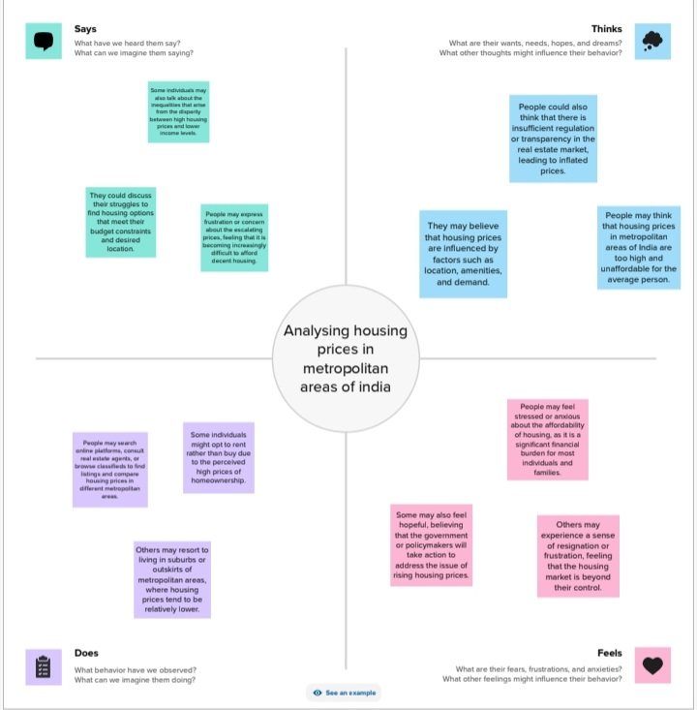

**BRAINSTORMING MAP:**

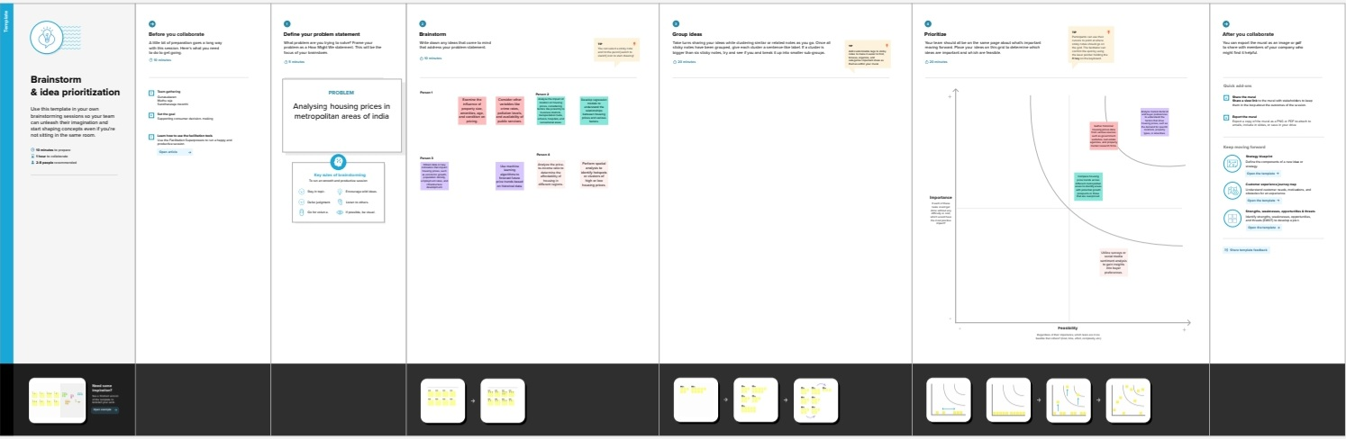

**ADVANTAGES:**

1. **Investment Opportunities**: Understanding housing prices can help investors identify areas with the potential for good returns on investment. It allows them to make informed decisions about when and where to invest in real estate.
2. **Market Trends**: Housing price analysis reveals market trends, such as price appreciation, demand-supply imbalances, and housing market cycles. This information is crucial for long-term investment and strategic planning.
3. **Homebuying Decisions**: For potential homebuyers, analyzing housing prices helps in making informed decisions about affordability, neighborhoods, and timing for purchasing a property.
4. **Risk Mitigation**: It helps individuals and businesses manage risks associated with property investments by identifying areas where prices are likely to remain stable or appreciate over time.
5. **Policy Formulation**: Policymakers can use this data to create effective housing policies and regulations, such as affordable housing initiatives, to address housing affordability issues and urban development challenges.
6. **Urban Planning**: City planners can use housing price data to understand population migration trends, assess housing demand, and plan infrastructure development to accommodate growing urban populations.
7. **Socioeconomic Research**: Researchers can use housing price data to study the socioeconomic dynamics of metropolitan areas, exploring factors like income inequality, housing affordability, and their impact on communities.
8. **Forecasting**: Housing price analysis allows for forecasting future trends in metropolitan areas, helping stakeholders anticipate potential shifts in the market.
9. **Comparative Analysis**: Comparing housing prices across different metropolitan areas in India can provide insights into regional disparities, economic growth, and the attractiveness of specific cities for investment and living.
10. **Financial Planning**: Understanding housing prices can be essential for financial planning and budgeting, helping individuals and families manage their expenses, including mortgage payments.
11. **Real Estate Development**: Developers can make informed decisions about where to build new properties, based on market demand and price trends.
12. **Impact on Other Sectors**: Housing prices can have a significant impact on related industries, such as banking, construction, and retail, making it important for these sectors to monitor and respond to changes in the housing market.
13. **Quality of Life**: Analyzing housing prices in metropolitan areas can provide insights into the quality of life, infrastructure, and amenities available in different neighborhoods, which is valuable information for residents and potential homebuyers.
14. **Data-Driven Decision Making**: In an era of data-driven decision-making, housing price analysis is essential for making well-informed choices regarding real estate investments and urban development.Top of Form

**DISADVANTAGES:**

1. **Data Accuracy**: Data accuracy can be a significant issue. In India, real estate transactions often involve underreporting of property prices to evade taxes. This can lead to discrepancies in the data and make it challenging to obtain a clear picture of actual market conditions.
2. **Data Fragmentation**: Real estate data in India is often fragmented and not readily available in one centralized database. This can make it time-consuming and difficult to gather comprehensive and up-to-date information.
3. **Volatility**: Housing prices in metropolitan areas can be highly volatile and subject to rapid fluctuations. This volatility can make it challenging to predict future trends accurately.
4. **Regional Variation**: India is a diverse country with significant regional variations in terms of culture, economy, and real estate market dynamics. Analyzing housing prices without considering regional differences can be misleading.
5. **Lack of Transparency**: Lack of transparency in the real estate sector can lead to discrepancies and discrepancies in property valuations. It can be challenging to assess the actual value of a property accurately.
6. **Data Manipulation**: Some developers and market participants might manipulate data to create an illusion of higher demand or price appreciation, which can mislead investors and homebuyers.
7. **Incomplete Information**: Housing price analysis may not capture all relevant factors, such as property condition, infrastructure development, and local amenities. This incomplete information can affect the accuracy of predictions.
8. **Market Speculation**: Speculation in the real estate market can lead to inflated prices that are not necessarily driven by underlying demand or economic fundamentals. This can distort the analysis.
9. **Government Policies**: Frequent changes in government policies related to real estate, such as tax regulations and land use policies, can have a significant impact on housing prices. These policy changes can be difficult to anticipate.
10. **Economic Factors**: The real estate market is influenced by various economic factors, such as interest rates, inflation, and GDP growth. These external factors can make housing price analysis more complex.
11. **Housing Bubble Risk**: Analysis may not always accurately predict housing bubbles, which can result in significant market crashes and financial losses for investors and homeowners.
12. **Overreliance on Historical Data**: Relying solely on historical data for analysis may not capture rapid changes in market dynamics, particularly in the fast-paced Indian real estate market.
13. **Impact of Pandemics and External Events**: Unforeseen events like pandemics, natural disasters, or economic crises can have a sudden and profound impact on housing prices, making it challenging to predict and analyze these scenarios.
14. **Investor Sentiment**: Investor sentiment and market psychology can play a significant role in influencing housing prices, often beyond what fundamental analysis suggests.Top of Form

**APPLICATIONS:**

1. **Home Buying and Renting Decisions**: Individuals and families can use housing price analysis to make informed decisions about purchasing or renting properties in metropolitan areas. They can identify affordable neighborhoods, compare prices, and assess future growth potential.
2. **Real Estate Investment**: Investors can use housing price data to identify lucrative investment opportunities. This includes selecting properties with the potential for appreciation and calculating potential returns on investment.
3. **Market Research for Developers**: Real estate developers can conduct market research to identify areas with high demand and favorable price trends. This helps in making informed decisions about where to construct new residential and commercial projects.
4. **Risk Assessment**: Investors, both individual and institutional, can use housing price analysis to assess risk associated with real estate investments. This involves understanding the volatility and stability of the market.
5. **Real Estate Appraisals**: Real estate professionals, including appraisers and agents, use housing price analysis to determine the value of properties for sales, purchases, or refinancing.
6. **Urban Planning**: City planners and local authorities use housing price data to make decisions about land use, zoning regulations, and infrastructure development. This is vital for managing urban growth and ensuring sustainable development.
7. **Policy Formulation**: Policymakers use housing price data to create and modify policies related to housing affordability, taxation, and urban development. This can include initiatives to address affordable housing shortages.
8. **Credit Scoring**: Financial institutions use housing price data when assessing credit applications, as it provides insights into the collateral's value and borrower's ability to repay loans.
9. **Portfolio Management**: Asset management firms and investment funds use housing price analysis to make strategic decisions about their real estate portfolios, including buying, selling, and diversification.
10. **Insurance Pricing**: Insurance companies use housing price data to determine property insurance rates and assess potential risk.
11. **Research and Academia**: Researchers and academics use housing price data to conduct studies and publish research on various aspects of the real estate market, urban development, and economic trends.
12. **Market Predictions**: Analysts and consultants use housing price analysis to make predictions about future market trends, helping businesses and investors plan their strategies.
13. **Gentrification Analysis**: Housing price analysis can be used to identify neighborhoods undergoing gentrification, which can have social and economic implications.
14. **Property Taxation**: Local governments use housing price data to determine property tax rates and assess the tax base for a region.
15. **Affordable Housing Initiatives**: Non-profit organizations and governmental agencies use housing price data to target areas where affordable housing initiatives are needed most.
16. **Home Improvement and Renovation Planning**: Homeowners can use housing price data to assess the potential return on investment for home improvement and renovation projects.
17. **Real Estate Marketing**: Real estate marketing professionals use housing price data to inform their marketing strategies and pricing recommendations for sellers.
18. **Tenant Rights and Advocacy**: Tenant advocacy groups may use housing price analysis to understand rent trends and advocate for tenant rights.

**CONCLUSION:**

In conclusion, analyzing housing prices in metropolitan areas of India is an essential and multifaceted process with far-reaching implications. It serves a wide range of stakeholders and offers numerous advantages, but it also comes with certain disadvantages and challenges that need to be addressed. By examining housing prices, individuals, investors, policymakers, and researchers can make more informed decisions and gain a better understanding of the complex dynamics within these urban real estate markets.

Housing price analysis empowers homebuyers to find affordable and suitable properties, provides investors with opportunities for financial growth, and assists real estate developers in selecting strategic locations for construction. For policymakers and city planners, this data is instrumental in shaping urban development policies and addressing housing affordability issues. Furthermore, housing price analysis informs real estate professionals, academics, and researchers, aiding in market predictions, research, and policy formulation.

While data accuracy, volatility, and regional variations can pose challenges, these can be mitigated through diligent data collection and the consideration of qualitative and quantitative factors. Ultimately, understanding the housing market in metropolitan areas of India is pivotal in addressing issues of housing affordability, urban development, and investment decisions, contributing to the overall growth and sustainability of these dynamic urban centers.

**FUTURE SCOPE:**

1. **Advanced Data Analytics**: With the increasing availability of data and advancements in analytics and artificial intelligence, the accuracy and predictive capabilities of housing price analysis will improve. This will enable more precise forecasts and better decision-making.
2. **Big Data Integration**: Integration of big data sources, including social, economic, and environmental data, will provide a more comprehensive view of housing markets. Analyzing a wide range of variables can help in understanding complex market dynamics.
3. **Real-Time Data**: The use of real-time data from sources like real estate websites and government agencies will become more prevalent. This will allow for more up-to-date and accurate assessments of housing market conditions.
4. **Machine Learning and AI Models**: Machine learning and AI models will play a crucial role in identifying trends, predicting market fluctuations, and improving data-driven decision-making for investors, policymakers, and homebuyers.
5. **Blockchain Technology**: Blockchain can enhance transparency and trust in real estate transactions. It can be used for property records and transactions, reducing fraud and improving data accuracy for analysis.
6. **Geospatial Analysis**: The use of geospatial technology and geographic information systems (GIS) will provide valuable insights into the spatial distribution of housing prices, helping to understand the impact of location on property values.
7. **Sustainability Analysis**: With a growing focus on sustainability, future housing price analysis will likely consider the impact of green building practices, energy efficiency, and environmental factors on property values.
8. **Affordable Housing Initiatives**: As affordable housing remains a significant concern, housing price analysis will be used to identify areas where affordable housing initiatives are needed and assess their effectiveness.
9. **Market Segmentation**: Analyzing housing markets based on different segments, such as luxury housing, affordable housing, or commercial real estate, will become more common. This allows for a more detailed understanding of diverse market dynamics.
10. **Government Initiatives and Policies**: As government policies continue to evolve, housing price analysis will be used to assess the impact of regulatory changes, incentives, and subsidies on the real estate market.
11. **Economic and Demographic Trends**: Understanding the impact of economic trends, demographic changes, and urbanization on housing prices will be essential. This analysis can help predict future housing demands and preferences.
12. **Impact of Pandemics**: The COVID-19 pandemic has reshaped urban living preferences. Future housing price analysis will likely consider the impact of pandemics and health-related factors on housing markets.
13. **International Investment**: As India continues to attract international investors, housing price analysis will also assess the impact of foreign investment on property prices in metropolitan areas.
14. **Digital Platforms and Apps**: Housing price analysis tools and apps will become more accessible to the general public, allowing individuals to make more informed real estate decisions.
15. **Social and Cultural Factors**: A deeper exploration of social and cultural factors, including lifestyle trends, community development, and local culture, will play a role in understanding housing preferences.

**RESULTS:**

